**Date: 16/10/2025**

**Name: Md. Moshiur Rahman**

**ID: 0242220005101871**

**Section: 63_M2**

**CSE416**

**Lab Performance: 01**

**Problem-01**

**Code:**

<!DOCTYPE html>

<html lang="en">

<head>

<meta charset="UTF-8">

<meta name="viewport" content="width=device-width, initial-scale=1.0">

<title>Document</title>

<style>

h1, h2, h3, h4, h5, h6 {

color: red;

}

p {

color: rgb(47, 0, 255);

}

b, strong {

color: red;

}

i, em {

color: blue;

}

small {

color: gray;

}

del {

color: rgb(139, 125, 0);

}

ins {

color: green;

}

sub, sup {

color: rgb(219, 217, 217);

font-size: 12px;

}

</style>

</head>

<body>

<h1>Moshiur</h1>

<h2>Moshiur</h2>

<h3>Moshiur</h3>

<h4>Moshiur</h4>

<h5>Moshiur</h5>

<h6>Moshiur</h6>

<br>

<p>Myname is MD. Moshiur Rahman. I am From Gazipur.</p>

<b>MOshiur</b><br>

<strong>MOshiur</strong><br>

<i>MOshiur</i><br>

<em>MOshiur</em><br>

<small>MOshiur</small><br>

<del>MOshiur</del><br>

<ins>MOshiur</ins><br>

<h1>MOshiur<sub>Rahman</sub></h1><br>

<h1>MOshiur<sup>Rahman</sup></h1><br>

</body>

</html>

**Output:**

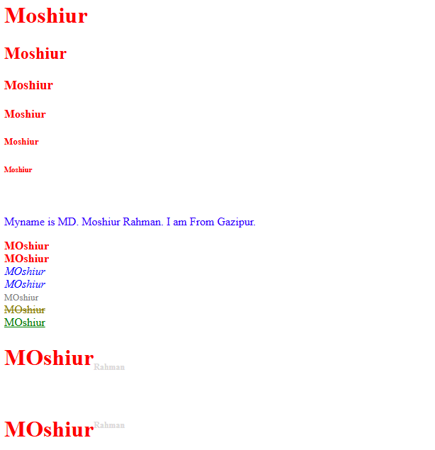

**Problem-02**

**Code:**

<!DOCTYPE html>

<html lang="en">

<head>

<meta charset="UTF-8">

<meta name="viewport" content="width=device-width, initial-scale=1.0">

<title>Document</title>

</head>

<body>

<!DOCTYPE html>

<html lang="en">

<head>

<meta charset="UTF-8">

<meta name="viewport" content="width=device-width, initial-scale=1.0">

<title>Employee Details Form</title>

</head>

<body>

<form>

<fieldset>

<legend>Employee Details</legend>

<label for="firstName">First name:</label> <input type="text" id="firstName" name="firstName" required><br><br>

<label for="lastName">Last name:</label><input type="text" id="lastName" name="lastName" required><br> <br>

<input type="radio" id="male" name="gender" value="Male" required><label for="male">Male</label>

<input type="radio" id="female" name="gender" value="Female"><label for="female">Female</label><br><br><br>

<label for="employeeID">Employee ID:</label> <input type="text" id="employeeID" name="employeeID" required><br> <br>

<label for="designation">Designation:</label> <input type="text" id="designation" name="designation" required><br><br>

<label for="phoneNumber">Phone Number</label> <input type="tel" id="phoneNumber" name="phoneNumber" required><br><br>

<button type="submit">Submit</button>

</fieldset>

</form>

</body>

</html>

</body>

</html>

**Output:**

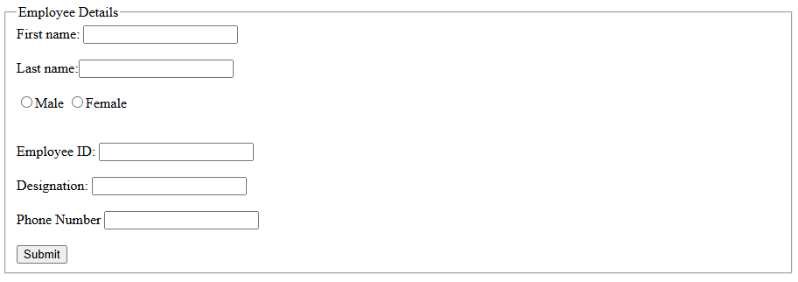

**Problem-03**

**Code:(HTML Code)**

<!DOCTYPE html>

<html lang="en">

<head>

<meta charset="UTF-8">

<meta name="viewport" content="width=device-width, initial-scale=1.0">

<title>Employee Details Form</title>

<link rel="stylesheet" href="Style.css">

</head>

<body>

<form>

<fieldset>

<legend>Employee Details</legend>

<label for="firstName">First name:</label> <input type="text" id="firstName" name="firstName" required><br><br>

<label for="lastName">Last name:</label><input type="text" id="lastName" name="lastName" required><br> <br>

<input type="radio" id="male" name="gender" value="Male" required><label for="male">Male</label>

<input type="radio" id="female" name="gender" value="Female"><label for="female">Female</label><br><br><br>

<label for="employeeID">Employee ID:</label> <input type="text" id="employeeID" name="employeeID" required><br> <br>

<label for="designation">Designation:</label> <input type="text" id="designation" name="designation" required><br><br>

<label for="phoneNumber">Phone Number</label> <input type="tel" id="phoneNumber" name="phoneNumber" required><br><br>

<button type="submit">Submit</button>

</fieldset>

</form>

</body>

</html>

**Code:(This is the “Style.css” File)**

body {

margin: 0;

padding: 0;

font-family: Arial, sans-serif;

background-color: #f4f4f4;

display: flex;

justify-content: center;

align-items: center;

min-height: 100vh;

}

form {

background-color: #ffffff;

padding: 30px;

border-radius: 10px;

box-shadow: 0 0 10px rgba(0, 0, 0, 0.1);

}

fieldset {

width: 350px;

padding: 20px;

border: 2px solid #333;

border-radius: 8px;

}

legend {

font-size: 1.2em;

font-weight: bold;

color: #333;

}

label {

color: #ff0000;

display: inline-block;

width: 120px;

margin-bottom: 10px;

}

input[type="text"],

input[type="tel"] {

width: calc(100% - 130px);

padding: 8px;

margin-bottom: 15px;

border: 1px solid #0044ff;

border-radius: 5px;

}

input[type="radio"] {

margin-left: 10px;

margin-right: 5px;

}

button[type="submit"] {

display: block;

margin: 20px auto 0;

padding: 10px 20px;

background-color: #0066cc;

color: #fff;

border: none;

border-radius: 5px;

font-size: 1em;

cursor: pointer;

transition: background-color 0.3s ease;

}

button[type="submit"]:hover {

background-color: #004d99;

}

**Output:**

